

FACULTY OF TECHNOLOGY AND ENGINEERING DEVANG PATEL INSTITUTE OF ADVANCE TECHNOLOGY AND RESEARCH

DEPARTMENT OF COMPUTER ENGINEERING

A.Y 2026 – 27 Semester – 3

LAB MANUAL

CSUC201 Fundamentals of Data Structures and Algorithms



Practical 3 — Sorting Algorithms: Comparison-Based, Counting-Based, and Digit-Based Strategies

Problem 1 — Sorting Answer Sheets (Bubble, Selection, Insertion)
Question:
A teacher has a stack of student answer sheets with marks written on them and needs to arrange them in order before entering grades. She tries three different methods: in the first, she repeatedly compares adjacent sheets and swaps them if they are out of order; in the second, she finds the lowest-marked sheet each time and places it at the front; in the third, she picks each sheet one by one and inserts it into its correct position among the already-arranged sheets. Implement all three methods and for each one, print the sorted order of marks.
Describe how each of the three methods works in your own words. If the sheets were already in order before the teacher started, which method would finish the fastest and why?

For Code :

https://github.com/kvvaghasiya49/FDSA/tree/6fb2f463bf1f58ac 408ada5ca8ffdaa64bc82087/DSA

Output :

Code (Bubble Sort):
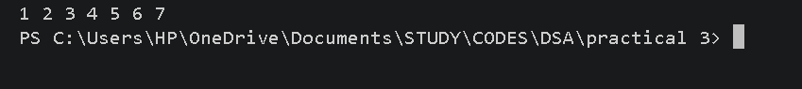

Code (Selection Sort):

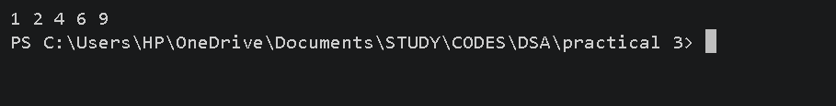

Code (Insertion Sort):

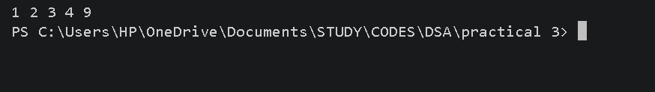

Problem 2 :

A paint shop has buckets labeled with one of three colour codes — 0, 1, or 2 — but they are
stored in a random order. The shop owner wants all 0s together, then all 1s, then all 2s, without
using any extra storage. Given the list of colour codes, rearrange them in place and print the
result.
Describe the approach you used. Does your solution make more than one pass through the list?
Can you think of a way to do it in exactly one pass?

For Code :

https://github.com/kvvaghasiya49/FDSA/tree/6fb2f463bf1f58ac40 8ada5ca8ffdaa64bc82087/DSA

Output :

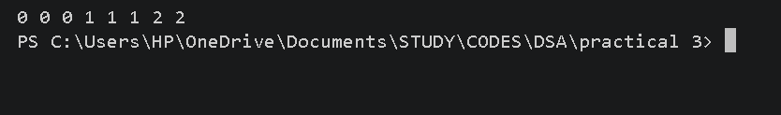

Challenges Faced:

For this problem, I used counting sort instead of the pointer-based approach — I counted how many 0s, 1s, and 2s were in the array using a small count array, and then rewrote the array by placing that many 0s, then 1s, then 2s back in order. It was easier to understand than tracking low, mid, and high pointers, but I had to be careful with the loop that places the values back so the counts matched correctly.

Learning Outcomes:

I learned that counting sort works well when there are only a few possible values (like 0, 1, 2), since I can just count and place them back.
I understood that this approach avoids complicated swapping logic, making it easier to write and trace through.
I learned that this method still takes O(n) time, just like the pointer-based approach, but is simpler to follow.
This helped me compare two different ways of solving the same problem and see how one can be easier to understand while the other avoids extra passes over data structurally.

Key Questions / Analysis / Interpretation to be Evaluated During/After Implementation

Que 1: One of the three methods can detect early that the list is already sorted and stop without doing any more work. Which method is it, how would you add that detection, and why can the other two not do the same?
Ans :

Bubble sort can detect this. If I add a flag that checks whether any swap happened during a pass, and no swap occurs, it means the array is already sorted, so I can stop early. Selection sort and insertion sort can't do this the same way — selection sort always scans the full unsorted part to find the minimum regardless of order, and insertion sort would need to check each element anyway to know if shifting is needed, so neither has a simple one-flag way to confirm the whole array is sorted early.

Que 2 :If your solution makes two passes through the list, can you identify which decision in your logic forces the second pass? Is there a way to restructure that decision to eliminate it?
Ans :

The counting step (counting how many 0s, 1s, and 2s exist) is separate from the placing step (writing them back into the array), which is why two passes happen. This is forced because I need the total counts before I can correctly place the values back. To reduce it to one pass, I'd need to know the positions while scanning, which isn't possible with plain.

Faculty Remarks:

